Secret Lives of Chandler’s Ford. A collection of fictional short stories is written by four local writers and available in several local stores.
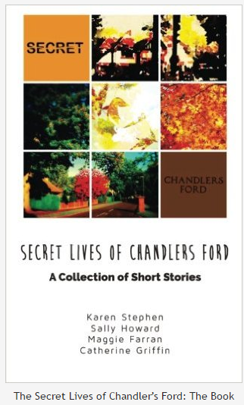
The Secret Lives of Chandler’s Ford: The Book

How the book began
Catherine, Karen, Maggie and Sally met at a creative writing class in Chandler’s Ford several years ago. Keen to develop their hobby, they formed a small writing group. The original aim was to discuss story ideas and read their work to each other.
After several meetings admiring one another’s kitchens, drinking coffee, eating cake and chatting, they thought it was time to get to work. The idea for a collection of short stories was born.
Each of the writers has their own individual style. However, they wanted a theme to unify the collection. As they all love Chandler’s Ford it became apparent that there could be no better backdrop to their stories. Who are these people who have found our secret heart?
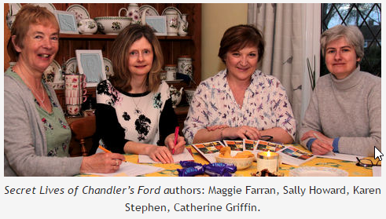
Secret Lives of Chandler’s Ford authors: Maggie Farran, Sally Howard, Karen Stephen, Catherine Griffin.

The authors
The writers live and work locally. They love the space and greenery of Chandler’s Ford, the choice of houses, well-regarded local schools, range of shops, cafes and pubs. They enjoy living in a thriving, varied, evolving suburban community. Like many of its inhabitants, the writers were not born or raised in Chandler’s Ford.
Catherine hails from Bristol. She has lived locally since the 1980s. A mathematician, she retired early and is now a full-time writer. Catherine is especially interested in reading and writing within the fantasy genre. She also enjoys writing contemporary stories with a twist. Catherine relaxes by pottering around her large garden.
Karen moved south from Scotland in the 1980s. She came to Chandler’s Ford for work reasons. Just for a couple of years, she thought. Eighteen years later, it seems she’s here to stay! Karen works full-time. She enjoys writing across several genres. She has contributed both historical and contemporary stories to the book. Karen loves theatre, books and socialising.
Sally is originally from the Midlands. She is a working mother of children and two naughty kittens. Sally enjoys writing for children and young adults. When she has spare time, Sally enjoys cooking and reading (sometimes at the same time, with mixed results). Her favourite type of holiday is a safari, which she hopes to introduce the children to in the near future.
Maggie is well-known in Chandler’s Ford. A teacher for many years at Hiltingbury School, former pupils often stop her for a chat. Maggie enjoys spending time with her children and grandchildren. Now she is retired from teaching, she does voluntary work. She also sings in a local choir. Maggie loves to write stories which are gentle, family-centred and often romantic.
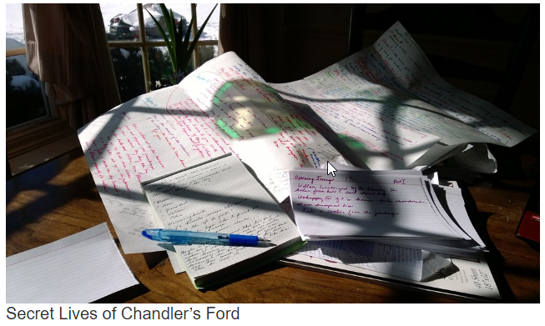

Secret Lives of Chandler’s Ford
The writers spent the summer and autumn of 2015 working on the collection of stories. The meetings became more organised. The group found a focus (but still enjoyed cake). What, they wondered, are the “secrets” of Chandler’s Ford? What goes on behind the net curtains and leafy hedges?

